
ROYAL FORENSICS PVT.LTD.

REPORT
Introduction:
As a part of my internship at ROYAL FORENSICS PVT. LTD., I, Chainika Dongre, gained practical exposure to email evidence collection methods. During the training, I learned the process of extracting and preserving email data from Gmail using Google Takeout and forensic tools such as BitRecover MBOX Converter Wizard and Advik Email Backup Wizard. The session focused on securely downloading mailbox data, converting email formats such as MBOX and EMLX, extracting attachments, and preparing the data for forensic examination and reporting. I also learned how to perform format conversion using Python-based EMLX to HTML conversion utilities.
- Email Backup using Google Takeout: Google Takeout is a service provided by Google that allows users to back up and download their Gmail data securely. It exports emails in MBOX format while preserving attachments, metadata, and folder structure, making it useful for backup, migration, and digital forensic purposes.
Steps for Email Backup using Google Takeout:
- Open Google Account Settings
- Open Gmail in a web browser.
- Click on the profile icon and select Manage your Google Account.
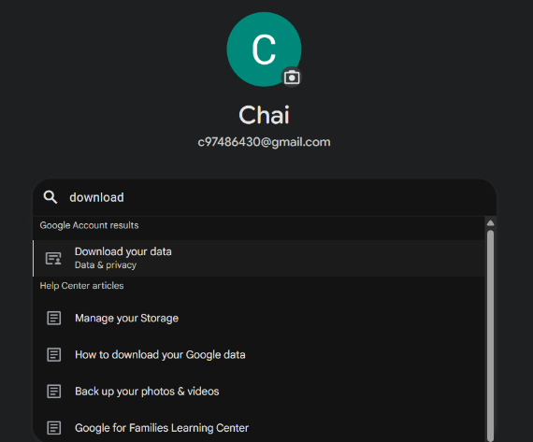
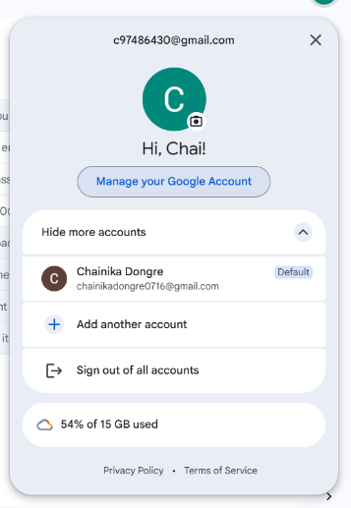
- In the search bar, type “Download your data” and open the Google Takeout page.

- Select Data to Export
- By default, all Google services are selected.
- Click “Deselect all”.
- Scroll down and select Mail.
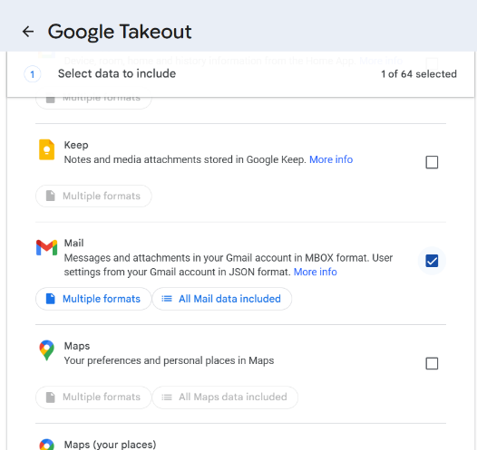
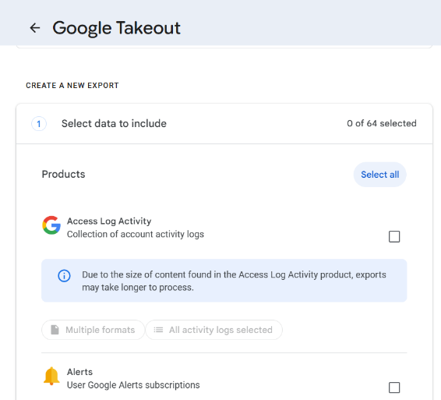

- Create Export
- Scroll down and click Next Step.
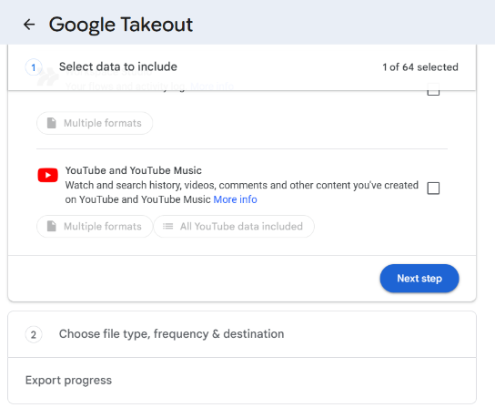
- Everything remains the same and click Create Export.
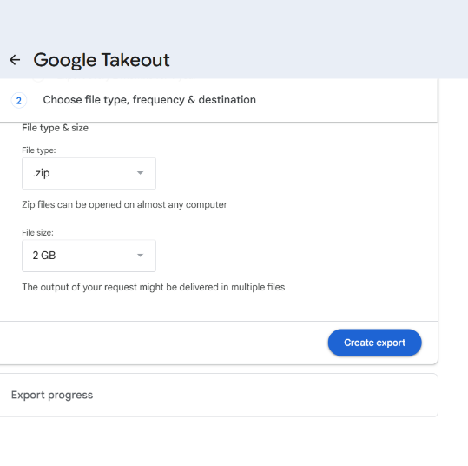

- Download the Takeout File
- After processing is complete, Google sends a download link to the Gmail inbox.
- Open the email received from Google Takeout.
- Click Download your files and save the exported ZIP file to the system.
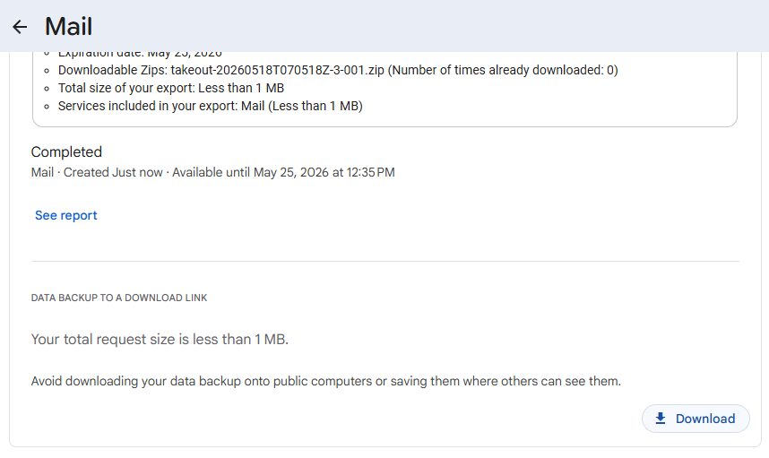
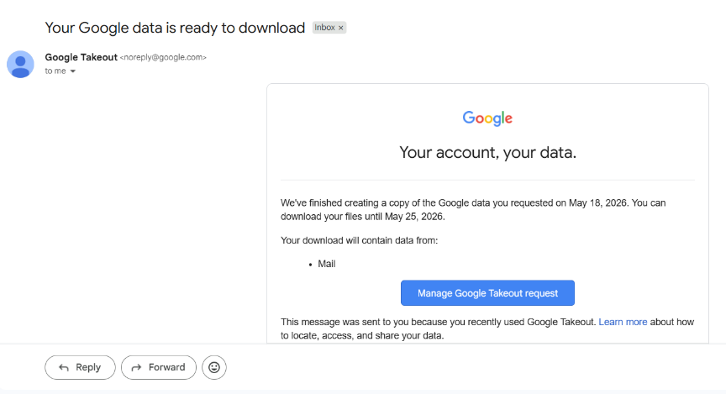

Converting MBOX File using BitRecover MBOX Converter Wizard
- Open BitRecover MBOX Converter Wizard
- Launch the BitRecover MBOX Converter Wizard application.
- Select the MBOX File
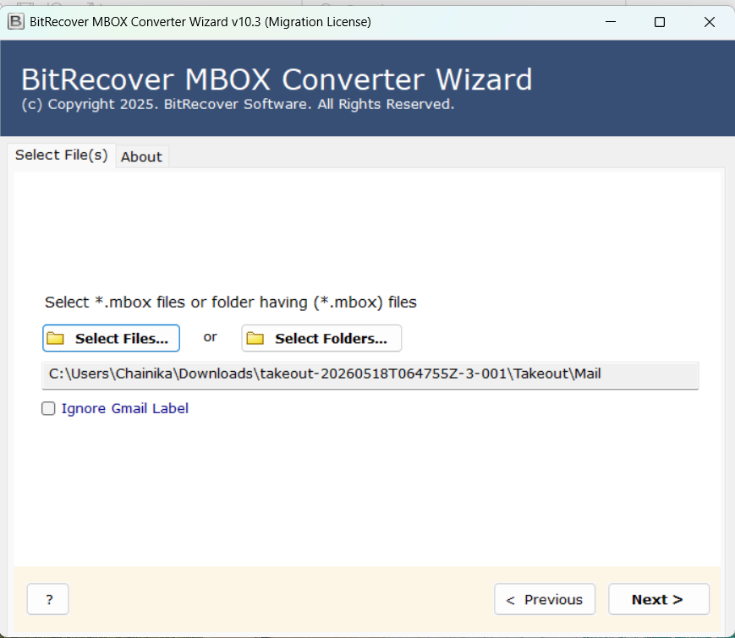
- Browse and select the extracted .mbox file obtained from Google Takeout.
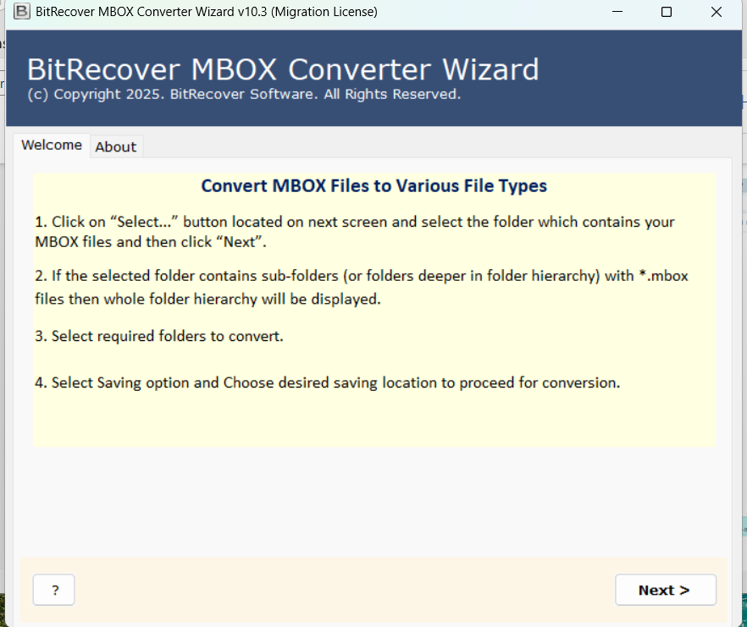
- Choose Export Settings
- Select the required email folders and options.
- Choose the saving format as EMLX.
- Set the destination folder path as required.
- Select the file naming option as:
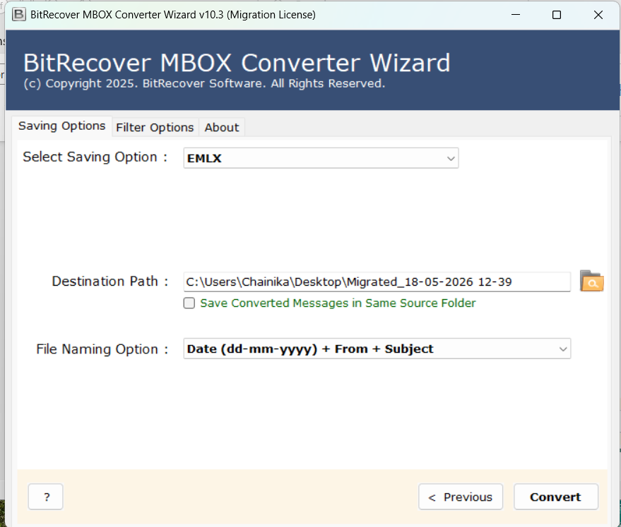
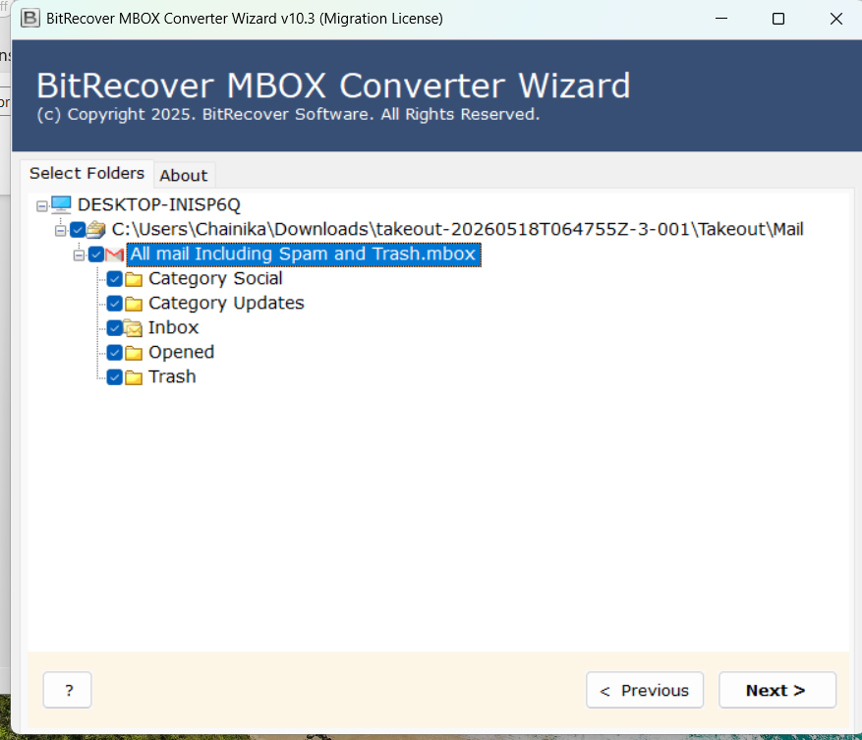
- Date + From + Subject

8. Start the Conversion Process
- Click Convert or Start to begin the conversion process.
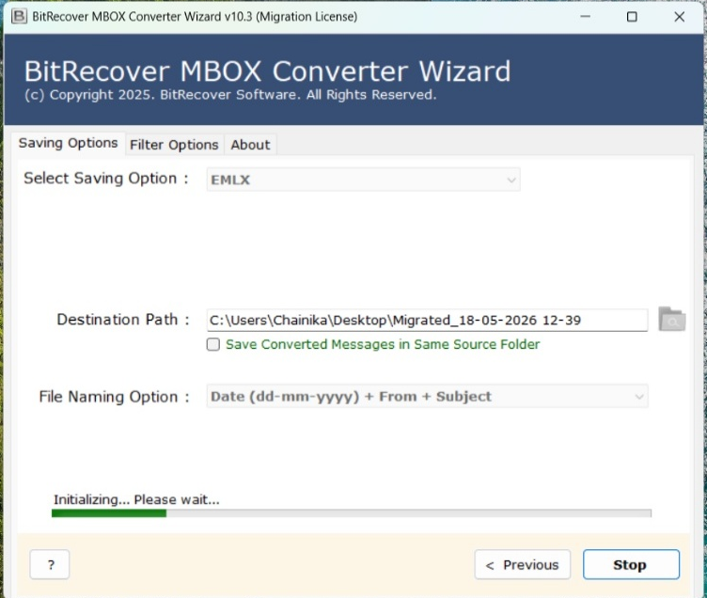
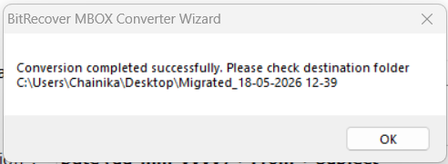
- Wait until the process is completed successfully.

EMLX to HTML Conversion using Python
9. Run the Python EMLX to HTML Converter
- Open the Python-based EMLX to HTML Converter tool.
- Select the folder containing converted .emlx files.
- Choose the output destination folder.
- Run the conversion process.
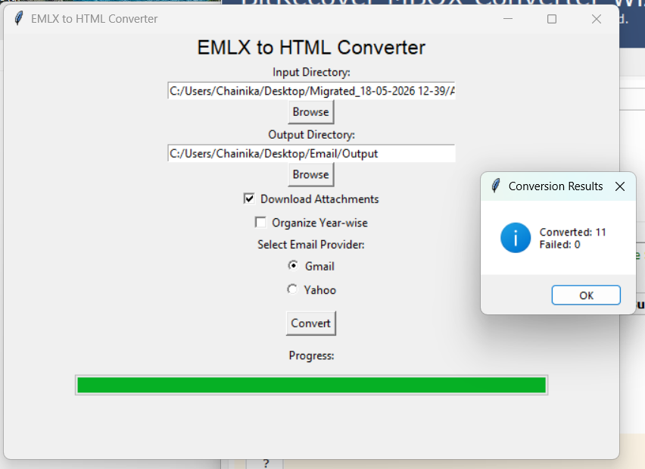
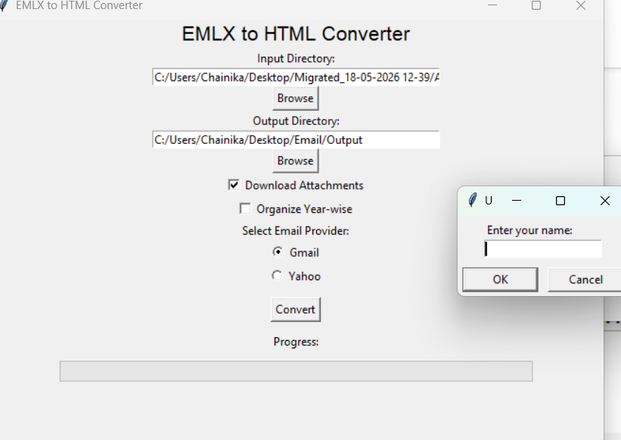
- The tool converts EMLX email files into HTML format for easy viewing and forensic analysis.

10. The output of Email Backup files will be saved in the HTML files.
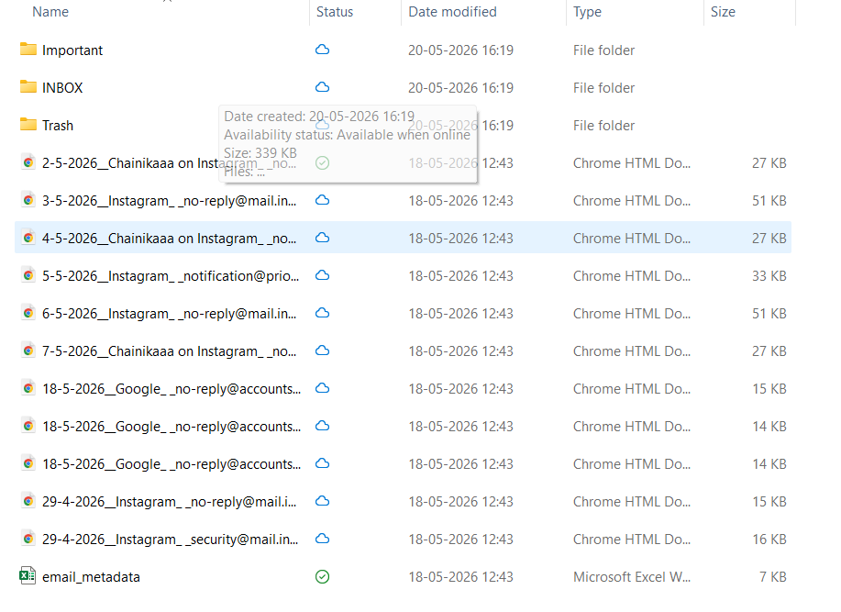

- EMLX conversion helps store every email separately with its original details, attachments, and formatting intact. This improves readability and ensures accurate results during HTML/PDF conversion and forensic analysis.

- Email Backup Using Advik Email Backup Wizard 12.2
Advik Email Backup Wizard is an email backup and migration tool used to securely extract and save emails from Gmail accounts. It allows users to download mailbox data in multiple formats such as EMLX, PST, PDF, and HTML while preserving email content, attachments, metadata, and folder structure. The tool is useful for email archiving, migration, and digital forensic investigations.
Steps for Email Backup using Advik Email Backup Wizard
  - Enable Two-Step Verification
- Open the Google Account settings.
- Go to Security.
- Find 2-Step Verification and turn it ON if it is disabled.
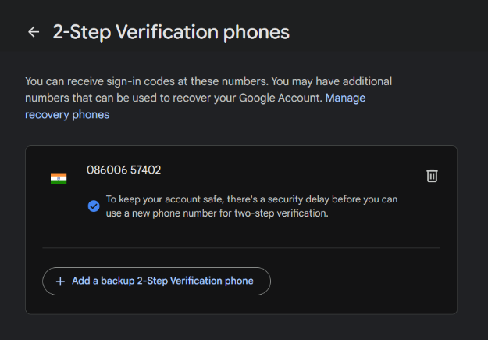
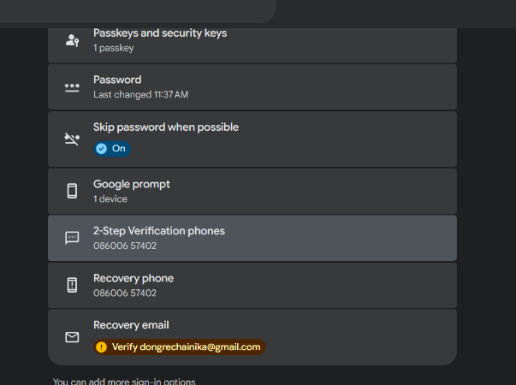

  - Generate an App Password
- In the Google Account search bar, search for App Passwords.
- Open the App Passwords section.
- In Select App, choose or enter a custom app name such as Gmail.
- Click Generate.
- A 16-character app password will appear.
- Copy and save this password securely.
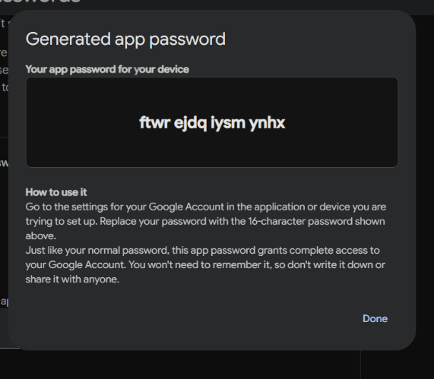
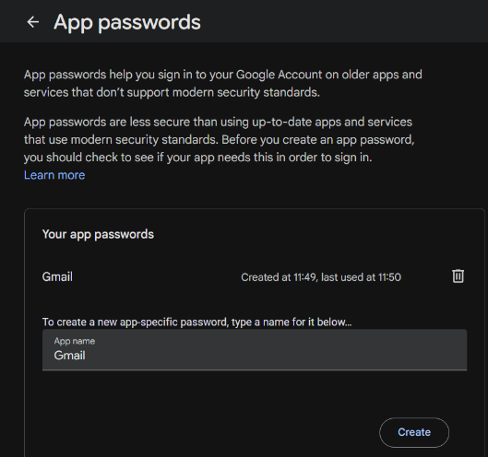

  - Open Advik Email Backup Wizard
- Launch the Advik Email Backup Wizard application.
- In Email Source, select Gmail.
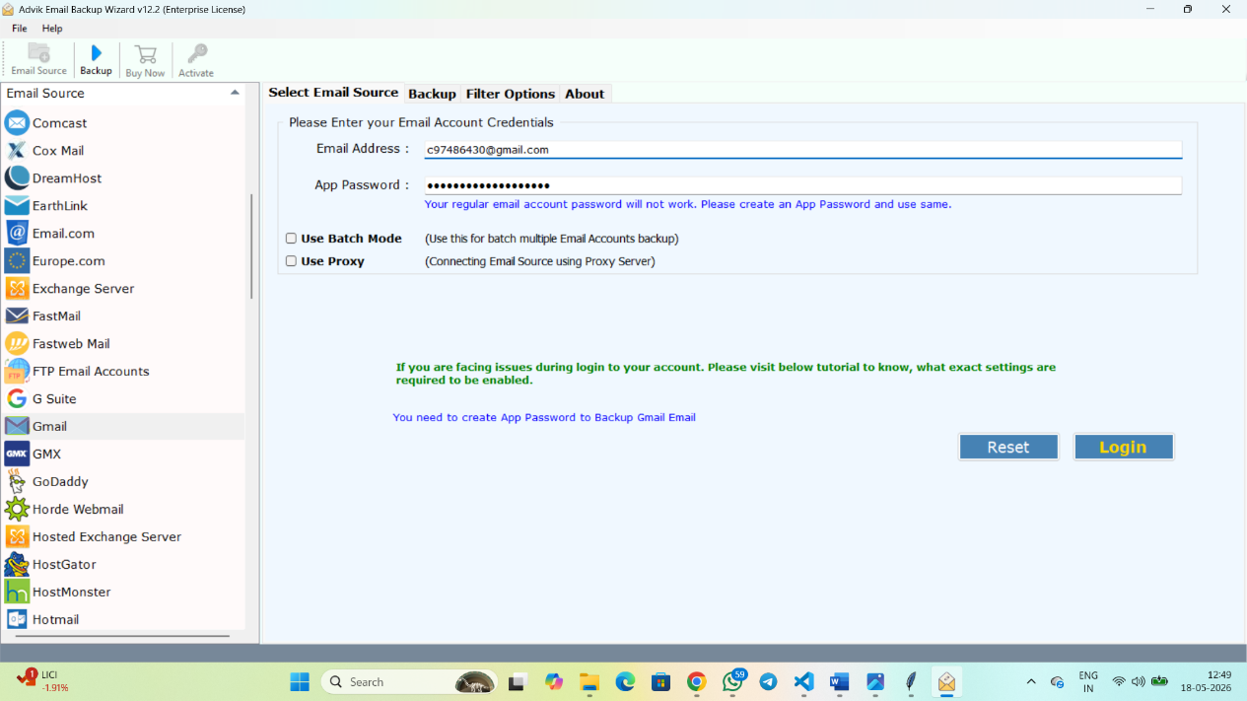

  - Login to Gmail Account
- Enter the Gmail email address.
- Paste the generated App Password in the password field.
- Click Login.

  - Select Backup Settings
- Choose the required mailbox folders such as: INBOX, IMPORTANT, SENT, DRAFTS, etc.
- Select the saving format as EMLX. Choose the destination folder path where the backup files will be stored.
- Click Backup or Start to begin the email extraction process.
- Wait for the backup process to complete successfully.
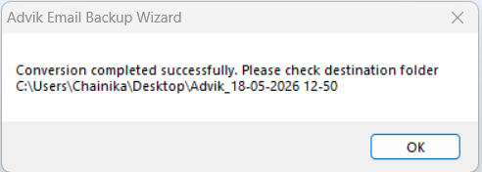
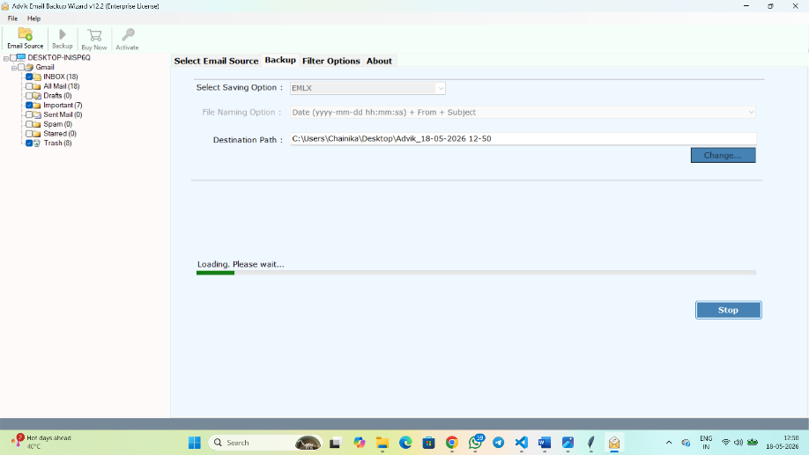

EMLX to HTML Conversion
  - Open the EMLX Converter Tool
- Launch the EMLX Converter tool.
- Add the folder containing the exported .emlx files.
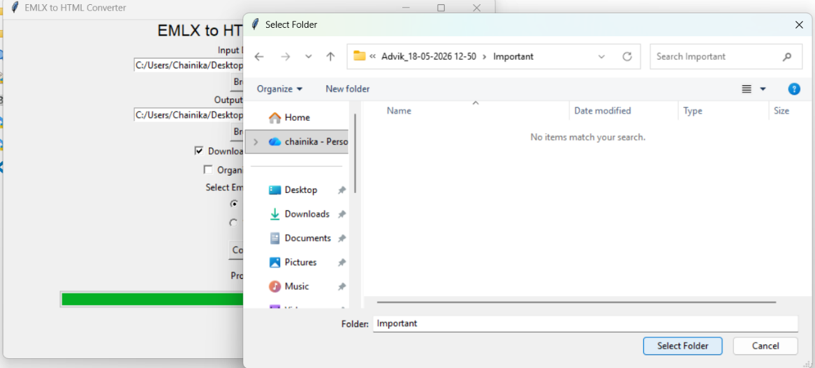

  - Enter the required name and email ID details.
  - Enable the Download Attachments option if attachments need to be extracted along with emails.

  - Click Convert to start the conversion process.
  - The EMLX files will be converted into HTML format for easier viewing, analysis, and reporting.
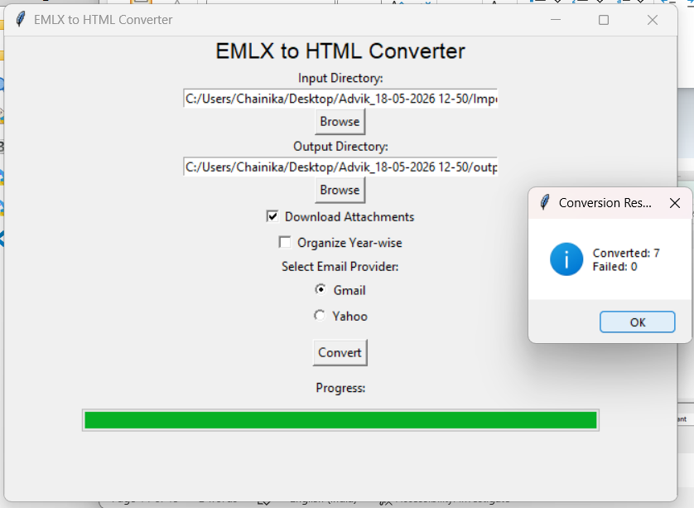

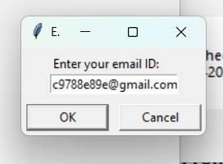

- Gmail emails were successfully backed up using Advik Email Backup Wizard and saved in EMLX format while preserving attachments, metadata, and folder structure for forensic analysis and reporting purposes.

